Creating a Impersonating Phishing Email But this time using HTML

Discussed as CEO asking targets to click on link and exploit PayPal website.

Tools you need

[https://github.com/htr-tech/zphisher.git- --](https://github.com/htr-tech/zphisher.git-%20--) zphisher

<https://github.com/trustedsec/social-engineer-toolkit.git> -- settoolkit

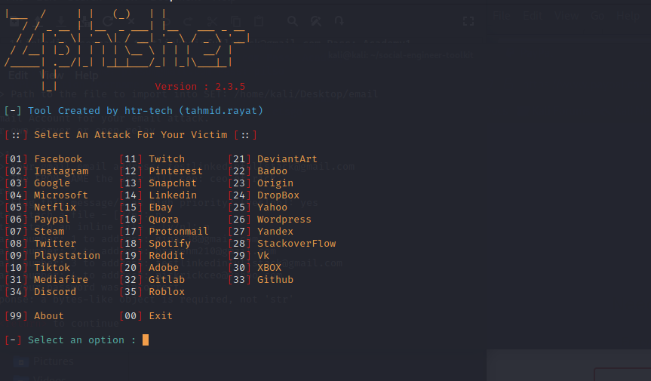

Use Paypal :06

After which you can use your local host

Press 01 for cloud flare.

No custom port

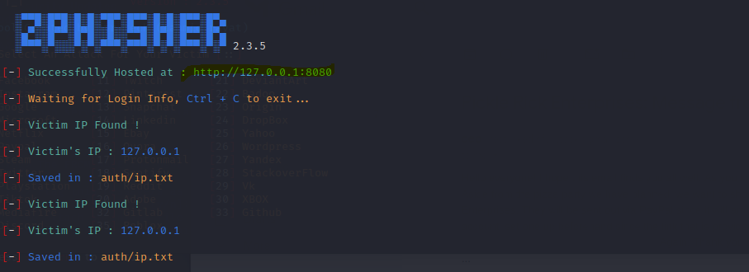

Use URL 1 and copy the link once we set up the settoolkit application.

Once your in the cd of social engineer toolkit

You need to run the program

Use 1 for Social Engineering attack

Then use 5 for Mass Mailer Attack

Once you have that make sure you create another text file where you put all your target emails and make sure you know the location of the email txt

/home/kali/Desktop/email

Once you have your target emails

Press 2 for mass mailer

Press 2 for one time use email template

Put in the subject

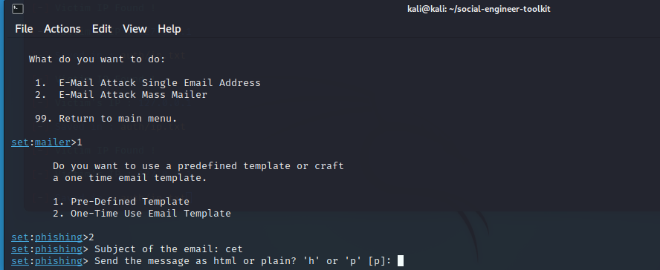

Ask for h to format it in html

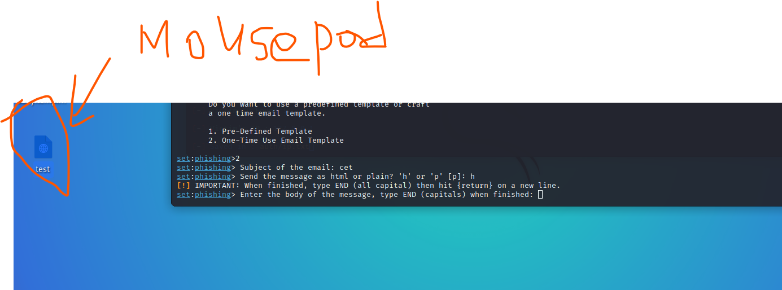

Take the html script you created and use mouse pad to copy the code over to Settoolkit

if you do you need to customize your (LINKED) using the zphisher and also bitly

Zphisher is to get the login credentials

And bitly is to mask the url

Once you have your zphisher url

<http://127.0.0.1:8080>

you need to take it to bitly so you can mask the url

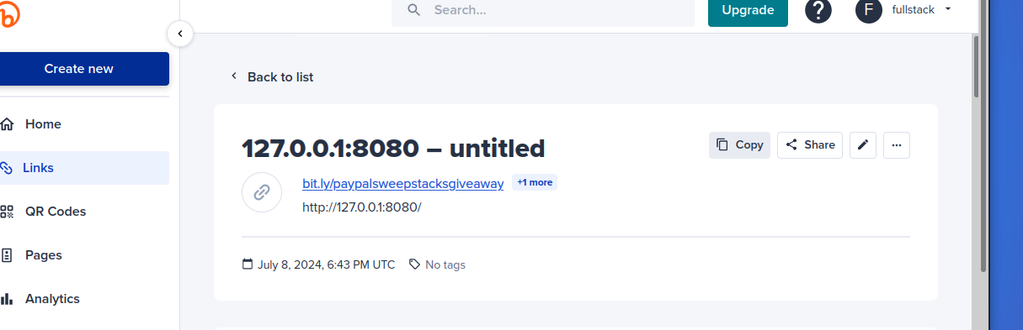

You also need to place the link in the specific code

That will create the login for paypal

Put in the file path.

Use for Gmail account for your email address

Press 1 and use your gmail account you created

For the From name the user will see just put in CEO or any other impersonating

It will ask for your password you will need to get it from the Gmail account you need to add an app to get the password to make this work.

We put it as high priority Yes

Do not attach a file

Do not inline the file as well.

I have sent it out and it would look something like this

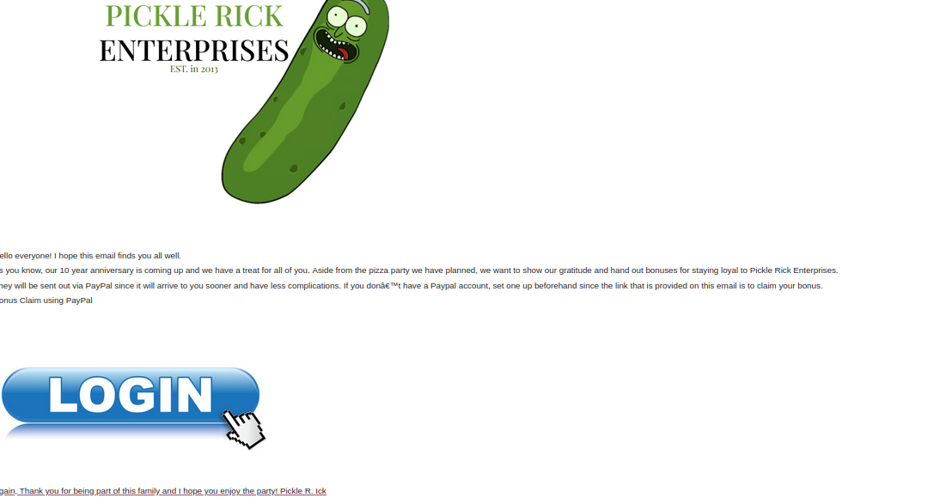

When the target clicks on the link it would automatically go to the paypal site

After which you can redirect the paypal site back to the main paypal site

Using bitly but you would need to pay for it.

